Little Big Horn College and its 6 Peer Colleges (December 2023)
LBHC selected three regional tribal colleges – Blackfeet Community College, Fort Peck Community College, and Stone Child College (all located in Montana) – and three national tribal colleges– Bay Mills Community College (Michigan), College of the Muscogee Nation (Oklahoma), and Lac Courte Oreilles Ojibwe College (Wisconsin) – for peer comparisons. See the American Indian Higher Education Consortium map for the location of these colleges.
These peer colleges are comparable to LBHC in their mission, size, demographics, and professional-technical/transfer mix. IPEDS was the only available source of data for comparing retention and graduation rates with peer colleges and disaggregated retention and graduation rate data were not available in IPEDS.
Peer colleges FTE
College | Peer | State | FTE undergraduate 2020-21
Little Big Horn College |  | MT | 267
Bay Mills Community College | National | MI | 318
Blackfeet Community College | Regional | MT | 186
College of the Muscogee Nation | National | OK | 191
Fort Peck Community College | Regional | MT | 321
Lac Courte Oreilles Ojibwe College | National | WI | 182
Stone Child College | Regional | MT | 233

Full-time adjusted fall cohort
 | 2012 | 2013 | 2014 | 2015 | 2016 | 2017 | 2018 | 2019 | 2020 | 2021
Little Big Horn College | 17 | 47 | 73 | 37 | 69 | 54 | 57 | 70 | 63 | 36
Bay Mills Community College | 112 | 94 | 92 | 84 | 57 | 60 | 0 | 4 | 2 | 4
Blackfeet Community College | 73 | 93 | 91 | 98 | 62 | 63 | 54 | 61 | 77 | 66
College of the Muscogee Nation |  | 40 | 33 | 41 | 55 | 51 | 51 | 65 | 59 | 54
Fort Peck Community College | 75 | 63 | 40 | 45 | 45 | 45 | 45 | 42 | 59 | 45
Lac Courte Oreilles Ojibwe University | 33 | 60 | 37 | 46 | 25 | 27 | 24 | 19 | 6 | 3
Stone Child College | 34 | 31 | 43 | 37 | 40 | 42 | 4 | 2 | 6 | 1
Average peer colleges | 327 | 381 | 336 | 351 | 284 | 288 | 178 | 193 | 209 | 173

Fall-to-fall retention rates for first time full-time students (%)
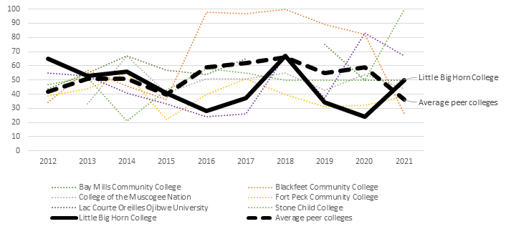

 | 2012 | 2013 | 2014 | 2015 | 2016 | 2017 | 2018 | 2019 | 2020 | 2021
Little Big Horn College | 65% | 53% | 56% | 41% | 28% | 37% | 67% | 34% | 24% | 50%
Bay Mills Community College | 44% | 55% | 67% | 57% | 54% | 65% | - | 75% | 50% | 50%
Blackfeet Community College | 34% | 57% | 46% | 36% | 98% | 97% | 100% | 89% | 82% | 26%
College of the Muscogee Nation | - | 33% | 67% | 41% | 51% | 51% | 55% | 43% | 54% | 44%
Fort Peck Community College | 39% | 44% | 55% | 22% | 40% | 51% | 40% | 31% | 32% | 38%
Lac Courte Oreilles Ojibwe University | 55% | 53% | 41% | 33% | 24% | 26% | 67% | 37% | 83% | 67%
Stone Child College | 47% | 52% | 21% | 43% | 58% | 55% | 50% | 50% | 50% | 100%
Average peer colleges | 42% | 51% | 51% | 40% | 59% | 62% | 66% | 55% | 59% | 36%

Graduation rate (%) for first time full-time students - within 150% of normal time
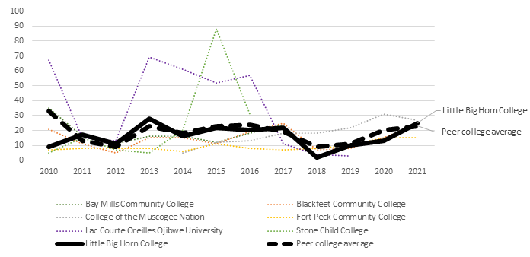

 | 2010 | 2011 | 2012 | 2013 | 2014 | 2015 | 2016 | 2017 | 2018 | 2019 | 2020 | 2021
Little Big Horn College | 9% | 17% | 11% | 28% | 16% | 22% | 20% | 22% | 2% | 10% | 13% | 25%
Bay Mills Community College | 35% | 16% | 11% | 16% | 16% | 12% | 18% | 24% | - | - | - | -
Blackfeet Community College | 21% | 11% | 5% | 15% | 15% | 11% | 19% | 25% | 7% | 8% | 15% | 25%
College of the Muscogee Nation | - | - | - | - | 5% | 12% | 13% | 18% | 18% | 22% | 31% | 27%
Fort Peck Community College | 7% | 8% | 8% | 8% | 6% | 11% | 8% | 7% | 8% | 10% | 15% | 15%
Lac Courte Oreilles Ojibwe University | 67% | 15% | 13% | 69% | 61% | 52% | 57% | 11% | 4% | 3% | - | -
Stone Child College | 5% | 15% | 7% | 5% | 20% | 88% | 31% | - | - | - | - | -
Peer college average | 33% | 13% | 9% | 23% | 18% | 23% | 24% | 19% | 9% | 11% | 20% | 23%

Graduation rate (%) for first time full-time students - within 200% of normal time
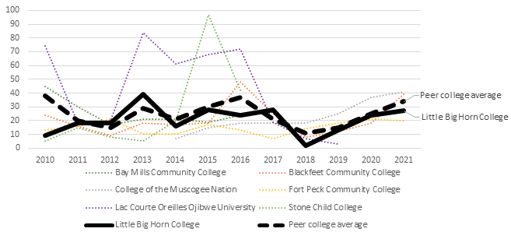

 | 2010 | 2011 | 2012 | 2013 | 2014 | 2015 | 2016 | 2017 | 2018 | 2019 | 2020 | 2021
Little Big Horn College | 9% | 18% | 18% | 39% | 16% | 28% | 24% | 28% | 2% | 13% | 24% | 27%
Bay Mills Community College | 45% | 30% | 17% | 21% | 21% | 19% | 24% | 27% | - | - | - | -
Blackfeet Community College | 24% | 16% | 9% | 18% | 17% | 18% | 48% | 25% | 8% | 12% | 18% | 39%
College of the Muscogee Nation | - | - | - | - | 7% | 15% | 18% | 18% | 18% | 25% | 37% | 41%
Fort Peck Community College | 13% | 16% | 21% | 10% | 10% | 17% | 13% | 7% | 14% | 18% | 21% | 20%
Lac Courte Oreilles Ojibwe University | 74% | 18% | 20% | 84% | 61% | 68% | 72% | 19% | 7% | 3% | - | -
Stone Child College | 5% | 15% | 8% | 5% | 20% | 97% | 42% | - | - | - | - | -
Peer college average | 38% | 20% | 15% | 29% | 21% | 30% | 37% | 21% | 11% | 15% | 25% | 34%

